**Example 1: Write a program in C++ to find the first 10 natural numbers.**

|  |
| --- |
| **#include <iostream>**  **using namespace std;**  **int main()**  **{**  **int i;**  **cout << " The natural numbers are: ";**  **for (i = 1; i <= 10; i++)**  **{**  **cout << i << " ";**  **}**  **cout << endl;**  **return 0;**  **}** |

**Output**

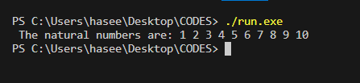

**Example 2: Write a program in C++ to find the sum of first 10 natural numbers.**

|  |
| --- |
| **#include <iostream>**  **using namespace std;**  **int main()**  **{**  **int i,sum=0;**  **cout << " The natural numbers are: \n";**  **for (i = 1; i <= 10; i++)**  **{**  **cout << i << " ";**  **sum=sum+i;**  **}**  **cout << "The sum of first 10 natural numbers: "<<sum << endl;**  **}** |

**Output**

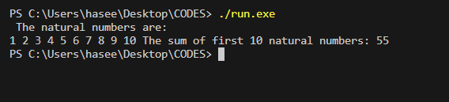

**Example 3: Write a program in C++ to display n terms of natural number and their sum.**

|  |
| --- |
| **#include <iostream>**  **using namespace std;**  **int main()**  **{**  **int n,i,sum=0;**  **cout << " Enter number of terms: ";**  **cin>> n;**  **cout << " The natural numbers upto "<< n <<"the terms are: \n";**  **for (i = 1; i <= n; i++)**  **{**  **cout << i << " ";**  **sum=sum+i;**  **}**  **cout << " The sum of the natural numbers is: "<<sum << endl;**  **}** |

**Output**

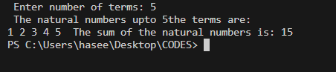

**Example 4: Write a program in C++ to find the factorial of a number.**

|  |
| --- |
| **#include <iostream>**  **using namespace std;**  **int main()**  **{**  **int num1,factorial=1;**  **cout << " Enter number to find the factorial: ";**  **cin>> num1;**  **for(int a=1;a<=num1;a++)**  **{**  **factorial=factorial*a;**  **}**  **cout<<" The factorial of the given number is: "<<factorial<<endl;**  **return 0;**  **}** |

**Output**

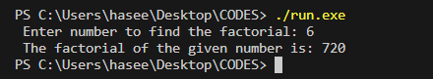

**Example 5: A person invests $ 1000.00 in a savings account yielding 5 % interest. Assuming that all interests is left on deposit in the account, calculate and print the amount of money in the account at the end of each year for ten years. Use the following formula for determining these amounts:**

**a = p(1 + r) ^2**

|  |
| --- |
| **#include <iostream>**  **#include <cmath>**  **#include <iomanip>**  **using namespace std;**  **int main()**  **{**  **double amount,**  **principal = 1000.0,**  **rate = .05;**  **cout << "Year" << setw( 21 )<< "Amount" << endl;**  **for ( int year = 1; year <=10; year++ )**  **{**  **amount = principal * pow( 1 + rate, year );**  **cout << setw( 4 ) << year << setw( 21 )<< amount << endl;**  **}**  **return 0;**  **}** |

**output**

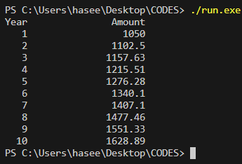

**Example 6: Write a program in C++ to check whether a number is prime or not.**

|  |
| --- |
| **#include <iostream>**  **using namespace std;**  **int main()**  **{**  **int num1, divi = 0;**  **cout << "--------------------------------------------\n";**  **cout << " Enter a number to check prime or not: ";**  **cin>> num1;**  **for (int a = 1; a <= num1; a++)**  **{**  **if (num1 % a == 0)**  **{**  **divi++;**  **}**  **}**  **if (divi == 2)**  **{**  **cout << " The entered number is a prime number. ";**  **}**  **else {**  **cout << " The number you entered is not a prime number.";**  **}**  **return 0;**  **}** |

**Output**

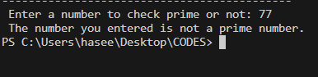

**Example 7: Basic Calculator using Switch statement.**

|  |
| --- |
| **# include <iostream>**  **using namespace std;**  **int main()**  **{**  **char op;**  **float num1, num2;**  **cout << "Enter operator: +, -, *, /: ";**  **cin >> op;**  **cout << "Enter two operands: ";**  **cin >> num1 >> num2;**  **switch(op)**  **{**  **case '+':**  **cout << num1 << " + " << num2 << " = " << num1 + num2;**  **break;**  **case '-':**  **cout << num1 << " - " << num2 << " = " << num1 - num2;**  **break;**  **case '*':**  **cout << num1 << " * " << num2 << " = " << num1 * num2;**  **break;**  **case '/':**  **cout << num1 << " / " << num2 << " = " << num1 / num2;**  **break;**  **default:**  **cout << "Error! operator is not correct";**  **break;**  **}**  **return 0;**  **}** |

**Output**

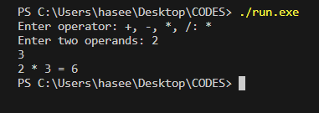

**Example 8: Menu based Basic Calculator using Switch statement.**

|  |
| --- |
| **#include<iostream>**  **using namespace std;**  **int main()**  **{**  **int choice;**  **long num1, num2, x;**  **cout << "Please choose your option:"**  **"1 = Addition\n "**  **"2 = Subtraction\n "**  **"3 = Multiplication\n "**  **"4 = Division\n "**  **"5 = Squares\n "**  **"6 = exit\n "**  **"Choice: ";**  **cin >> choice;**    **while(choice < 1 || choice > 6)**  **{**  **cout << "Please choose the above mentioned option."**  **"\nChoice: ";**  **cin >> choice;**  **}**  **switch (choice)**  **{**  **case 1:**  **cout << "Enter two numbers: \n";**  **cin >> num1 >> num2;**  **x = num1 + num2;**  **cout << "Sum = " << x;**  **break;**    **case 2:**  **cout << "Enter two numbers: \n";**  **cin >> num1 >> num2;**  **x = num1 - num2;**  **cout << "Subtraction = " << x;**  **break;**  **case 3:**  **cout << "Enter two numbers: \n";**  **cin >> num1 >> num2;**  **x = num1 * num2;**  **cout << "Product = " << x;**  **break;**  **case 4:**  **cout << "Enter Dividend: ";**  **cin >> num1;**  **cout << "Enter Divisor: ";**  **cin >> num2;**  **while(num2 == 0)**  **{**  **cout << "\nDivisor cannot be zero."**  **"\nEnter divisor once again: ";**  **cin >> num2;**  **}**  **x = num1 / num2;**  **cout << "\nQuotient = " << x;**  **break;**  **case 5:**  **cout << "Enter any number: \n";**  **cin >> num1;**  **x = num1 * num1;**  **cout << "Square = " << x;**  **break;**  **case 6:**  **return 0;**  **default: cout << "Error";**  **}**  **}** |

**Output**

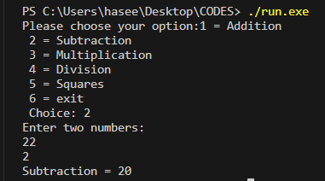

**Q: 1 2 3 6 18 13 21 34 55 89….**

|  |
| --- |
| #include <iostream>  using namespace std;  int main()  {  int a {1};  int b {1};  int othervalue {};  while (othervalue <= 65)  {  a;  othervalue = a + b;  cout << othervalue << ",";  a = b;  b = othervalue;  }    cout << "good ho gaya a.";  return 0;  } |

Output



**Q2 : 0 3 6 9 12 15 ..…**

|  |
| --- |
| #include <iostream>  using namespace std;  int main()  {  int a {0};  int b {3};      while (a < 100)  {  cout << a << “ ”;  a = a + b;  }  return 0;  } |

Output

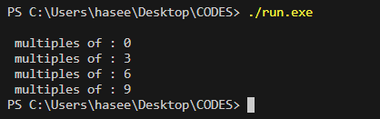

Reference from GPT.

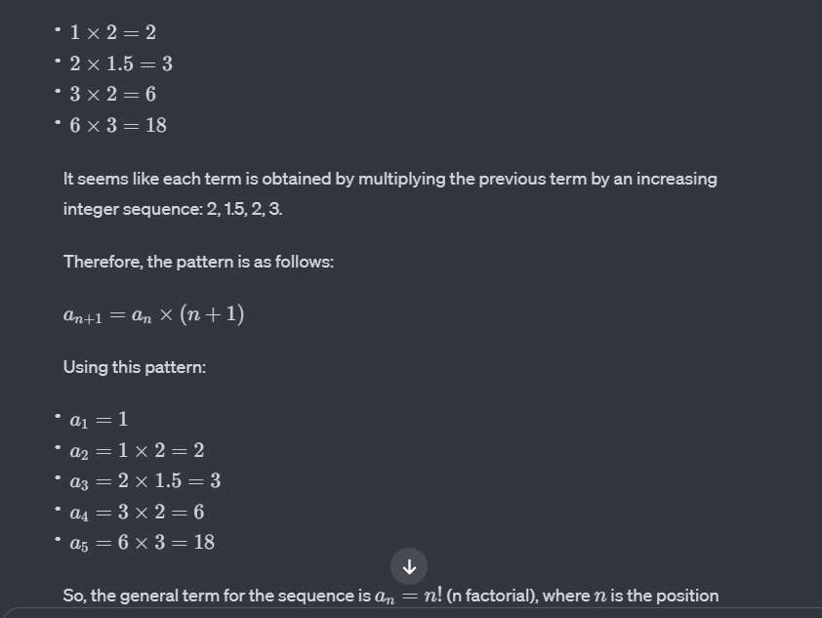

**Q3: 1 2 3 6 18**

|  |
| --- |
| #include <iostream>  using namespace std;  int main() {  int num = 1;  int i = 0;  while (i < 7) {  cout << num;  if (i < 6) {  cout << " ";  if (i % 2 == 0) {  num *= 2;  } else {  num *= 1.5;  }  }  ++i;  }  cout << endl;  return 0;  } |

Output

**Q4: 4000 1000 250 125 62 31 15 7 3 1.**

|  |
| --- |
| #include <iostream>  using namespace std;  int main() {    int value = 4000, num = 0;  for (int num = 0; value > num;)  {  cout << value << " ";  value /= 2;  }    return 0;  } |

Output

